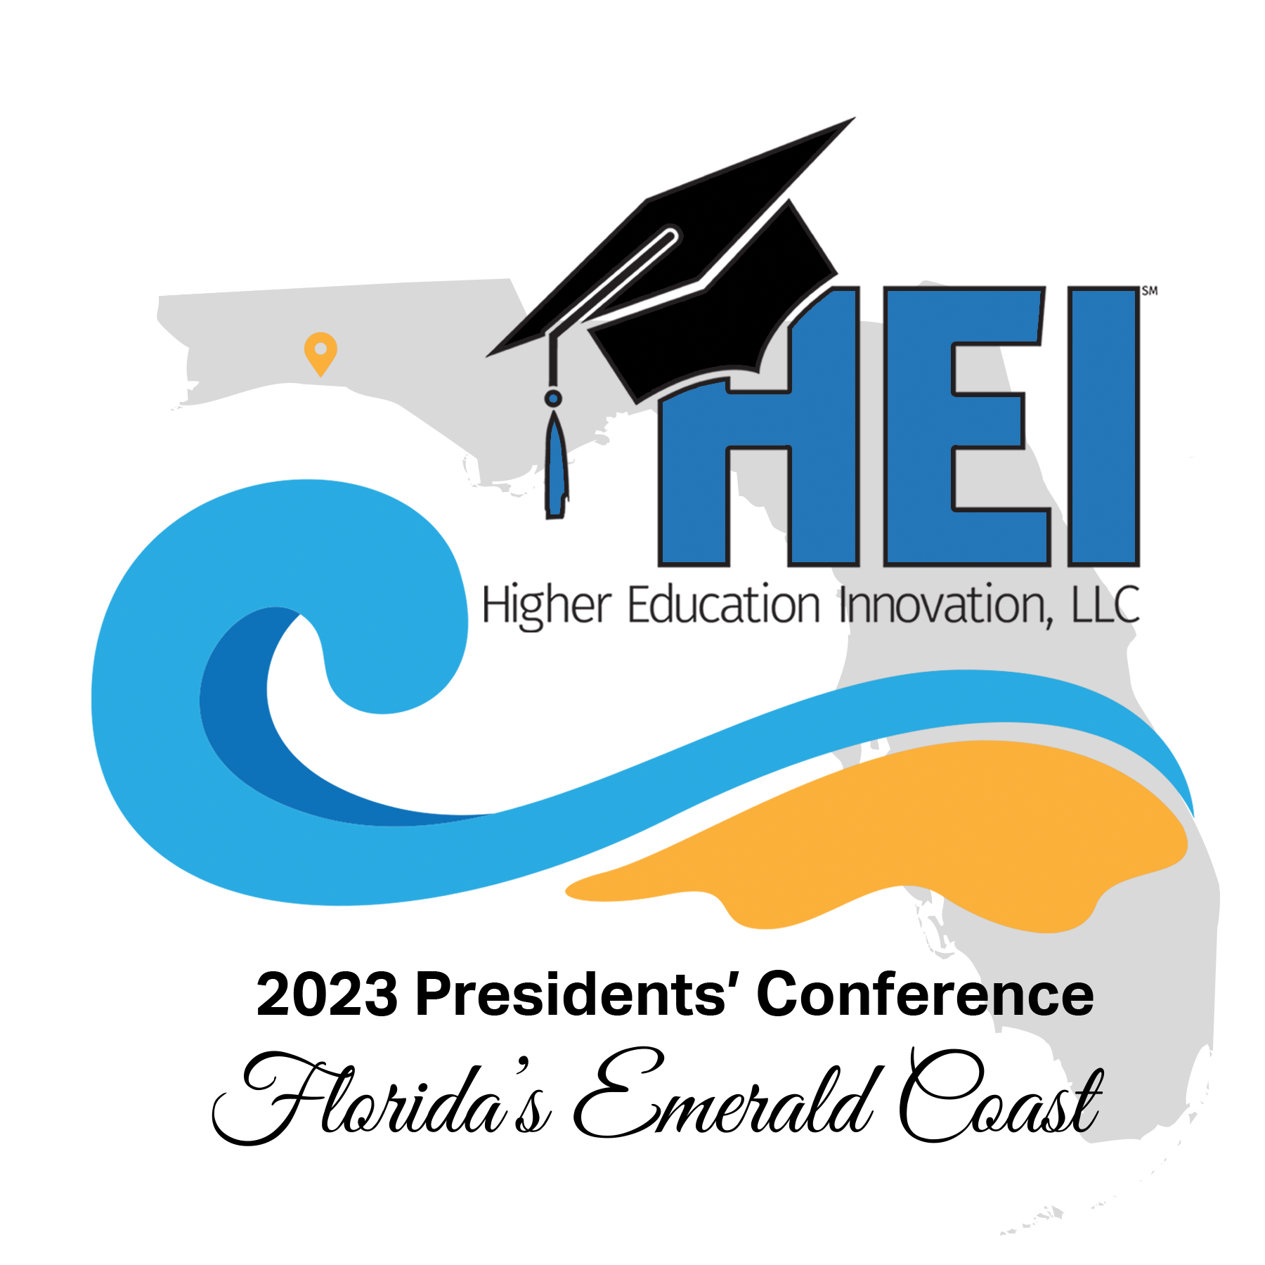
2023 Higher Education Innovation Presidents’ Conference
Call for Proposals for Innovative and Entrepreneuring best Practices Breakout Sessions

~October 9-10 in Niceville, Florida~

Co-Hosted by Northwest Florida State College and Florida State University-Panama City

THEME: “The Entrepreneuring Frontier: What Does the Future of Higher Education Look Like”

Some of the subtopics we are looking to include are:
  - The role of Artificial Intelligence in teaching and learning and/or institutional business practices,
  - How will colleges obtain and maintain financial stability in the future (especially with declining enrollment, political pressure to keep tuition low, and reduced funding from state legislatures),
  - What should be the new focus of Enrollment Management in an era of decreasing numbers of high school graduates,
  - How will technologies used in higher education evolve in the future,
  - How will colleges create an innovative employer-friendly workplace (addressing work-from-home options and using more virtual technologies to address work-related issues),
  - How will colleges partner with other educational institutions (both public schools and higher education institutions) and with business and industry to speed the time-to-degree, make work-and-learn opportunities common for students, and truly align curriculum and college credentials’ requirements with workplace certifications so as to provide employers with what they want in a future employee,
  - What will be the emerging role(s) of the college president in a highly political world, and
  - What will be the obstacles and opportunities for colleges as higher education attempts to transition from a seat-based, semester-length, credentials-focused institution to a competency-based, flexible-learning, certifications-focused delivery system of academic programing?

Guidelines for Proposals:

- Please submit a proposed title and a 150-200 word abstract for the session you would like to deliver.

- Please email the above to Dr. Mary Landon Darden at maryd@heitoday.org by May 22, 2023.

